Let’s Make it Grow: After-School Gardening
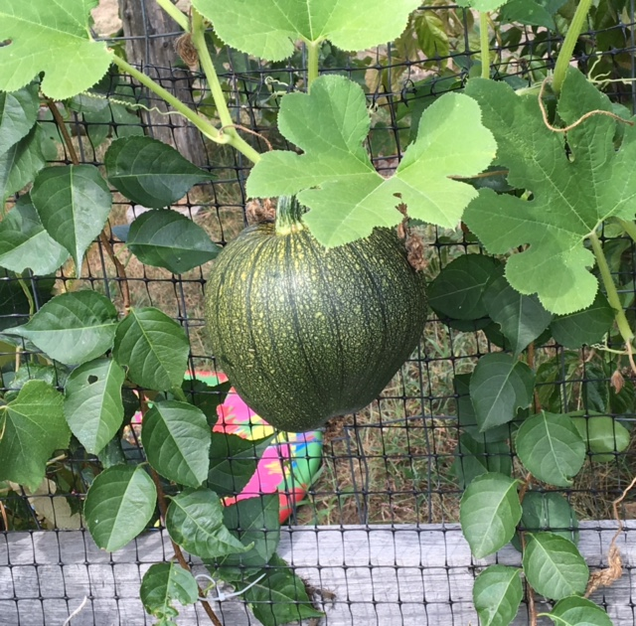

Target Group: Claypit Hill School Students in Grades 2-5
Location: Claypit Hill School Organic Garden
Dates: Wednesdays (Sept. 28, Oct. 5, 19, 26, Nov. 2
Time: 1:50 – 3:30 pm (rain or shine)
Enrollment: Minimum, 6; Maximum 8
Instructor: Ms. Coady, retired CH Grade Two Teacher

Snack Info: Please send a nut-free snack.

Let’s Make it Grow: After-School Gardening

Come ready to garden and to learn! We’ll plant vegetables, collect seeds, do lots of digging and weeding, look for worms and other signs of healthy soil, paint signs for the garden, pick raspberries, blueberries, strawberries, and fall vegetables.

Registration
If your child wants to join, please fill out the registration form and return with a $100 check payable to WSCP. In the memo section of your check, write “CH Gardening Program.” Please send registration form and payment to address below.

DEADLINE: Please register as soon as possible; need minimum of 6 participants.

Program Info: Deane_Coady@wayland.k12.ma.us Registration Info: Rosemarie_Teti@wayland.k12.ma.us

Wayland School Community Programs
47 Loker Street
Wayland, MA 01778
WSCP Registration
Claypit Hill School Fall 2016 Gardening

Student Information:

Child’s Name:
Grade:

Classroom Teacher:_____________________________________

Parent/Guardian’s Name: _________

Cell Phone Number:

Home Phone Number:

Email Address:

Emergency Contact Name:

Cell Phone Number:
Home Phone Number:

Allergy Information:

Please list any allergies, including food allergies:

Please list any medications taken regularly:

Snack Info: Please send a nut-free snack.

Please Initial Below:

I agree to allow my child to be photographed/videotaped during the after-school gardening class for possible use in brochures, newspapers, program websites and local cable television.

I do not agree to allow my child to be photographed/videotaped during the after-school gardening class

Signature of Parent/Guardian Date

Registration: Send this completed form with $100 check payable to WSCP (CH Gardening in memo) to: WSCP, Loker School, 47 Loker Street, Wayland, MA 01778

